Lead THE Cause Participants:

Lead THE Cause is only a little more than a month away! Time for some final paperwork!

If you are receiving this email you are registered and have at least made the first payment, so you are IN!

This email contains some of the final things that each of us needs to finalize all the registrations.

First: If you have not yet made your final payment, PLEASE SUBMIT YOUR FINAL PAYMENT BY MAY 31st. We want all money things taken care of well before we leave.

Second: Since you are receiving this email you have officially registered and paid (at least the first payment) with East White Oak. This means that your registration is paid for with our block of registrations, but Lead THE Cause still doesn't know who you are and/or with whom you'd like to room in Denver. The following instructions (with helpful step by step screenshots) will allow you to do this:

- Go to leadthecause.org

- Click on “Event Portal”

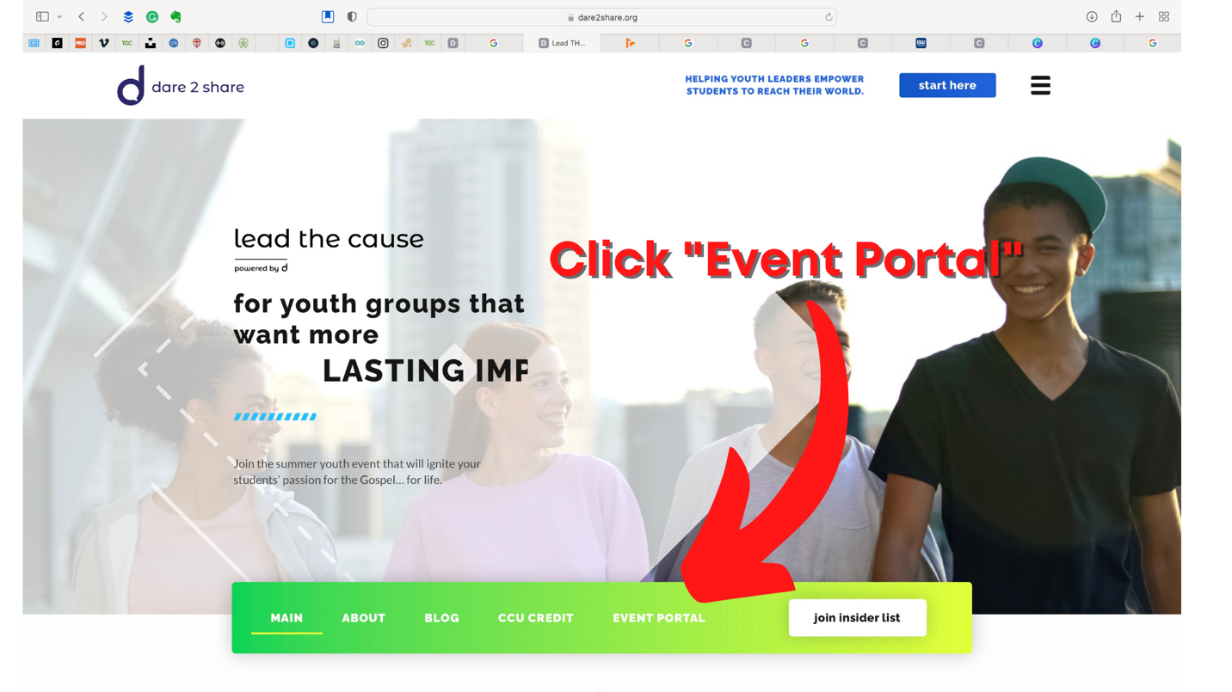
- Enter Password “LTC2022”
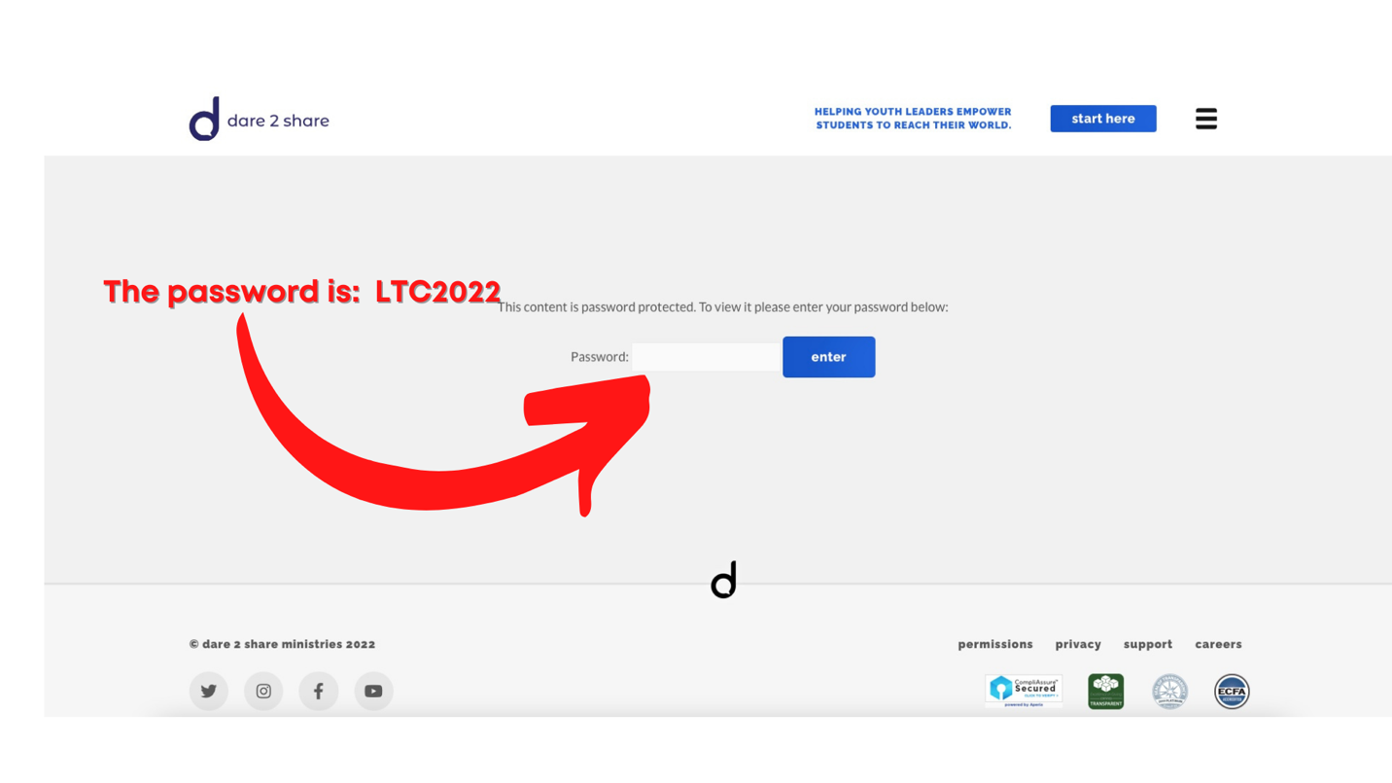
- Scroll down to near the bottom of the page and click on the appropriate “Registration Forms” box.

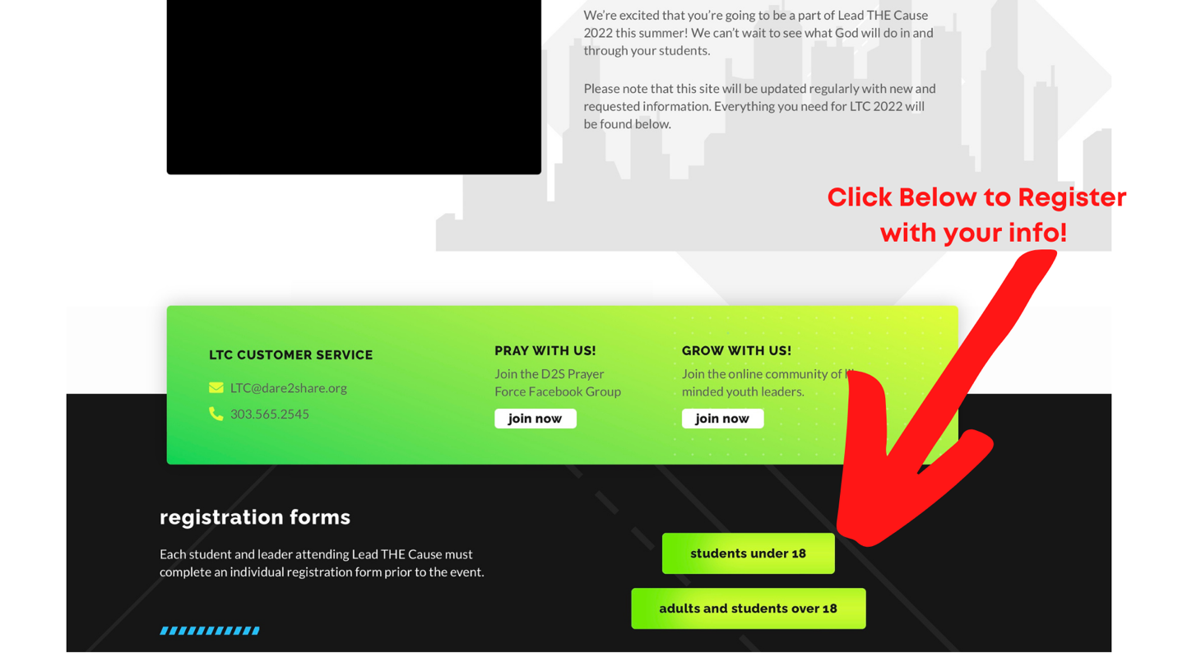

- Important! Fill out the first box EXACTLY as it is filled out in the screenshot. Very important that you get the right week, the right church, my name, and my email correct. Otherwise, you could be hanging out with some other church for the week!

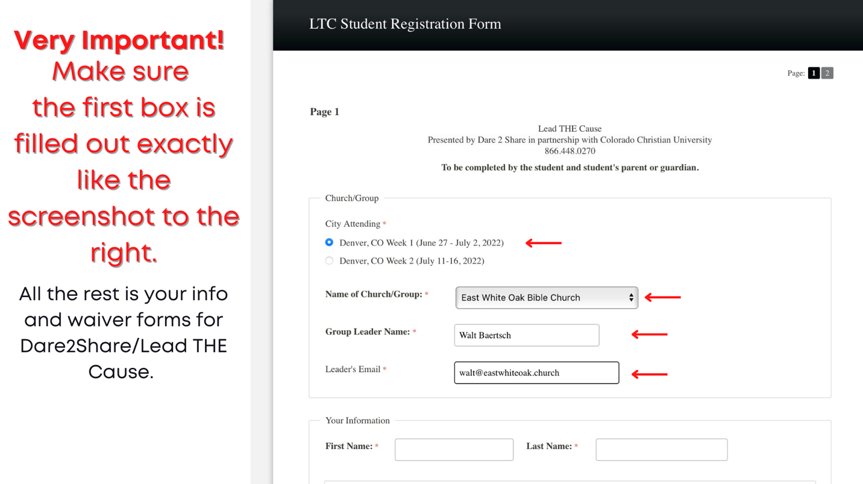

- If you made it this far you are now officially registered with Lead THE Cause! You and I should both receive confirmation emails indicating that you have completed your registration!

If you have any problems, contact me and I will be able to walk you through the steps.

Have a great day!

Looking forward to what God will do in us and through us this summer!

Pastor Walt

Mobile: 309-824-4009

p.s. I’m sorry I have a complicated last name to spell!

